Amna Amjad
24-ntu-cs-fl-1012
Homework-1
Part 1:
Theory Questions
Qno1:
Explain the difference between INPUT, INPUT_PULLUP, and OUTPUT modes on ESP32. Describe how a push button should be wired when using INPUT_PULLUP, what logic level is read when the button is pressed, and why GPIO selection and voltage limits matter.
The ESP32 has three common GPIO modes:
- INPUT
- INPUT_PULLUP
- OUTPUT.
INPUT is used to read signals from external devices such as buttons and sensors.
INPUT_PULLUP also reads input signals but enables an internal pull-up resistor, keeping the pin HIGH when the button is not pressed.
OUTPUT is used to send signals to control devices such as LEDs.
When using INPUT_PULLUP, one terminal of the push button is connected to GPIO 18 and the other to GND. When the button is pressed, the pin reads LOW (0), and when released, it reads HIGH (1).
GPIO selection is important because some pins have special functions or boot-related restrictions. Voltage limits must also be followed because ESP32 GPIO pins operate at 3.3V logic and are not 5V tolerant. Applying 5V directly to a GPIO pin can damage the ESP32.
Example :

const int buttonPin = 18;
const int ledPin = 2;

void setup() {
pinMode(buttonPin, INPUT_PULLUP);
pinMode(ledPin, OUTPUT);
}

void loop() {
if (digitalRead(buttonPin) == LOW) {
digitalWrite(ledPin, HIGH);
} else {
digitalWrite(ledPin, LOW);
}
}
The button uses INPUT_PULLUP, so pressing it reads LOW. The LED turns ON when the button is pressed and OFF when released.
Qno2:
What is the purpose of a timer in an embedded system? Compare delay()-based timing with millis()-based or timer-driven non-blocking timing. Give one practical example where non-blocking timing allows the display, button, and another task to remain responsive.
A timer in an embedded system is used to perform tasks at specific time intervals, such as updating a display, checking a button, or reading a sensor.
The delay() function stops the program for a specified period, preventing other tasks from running during that time.
millis() measures elapsed time without stopping the program, allowing multiple tasks to run responsively.
Timer-driven non-blocking techniques also allow tasks to execute at scheduled intervals.
For example:
ESP32 can use millis() to update an OLED display every second, check a push button continuously, and read a temperature sensor at regular intervals. This keeps all tasks responsive without blocking the program.

unsigned long previousTime = 0;

void loop() {
if (millis() - previousTime >= 1000) {
previousTime = millis();
Serial.println("Display update");
}

// Check button and perform other tasks here
}

The message prints every second without stopping the program, so the button and other tasks can continue running.

Qno3:
Define an interrupt and an Interrupt Service Routine (ISR). Explain the sequence from an interrupt event to ISR execution. State at least three good ISR practices for ESP32 Arduino code, and explain why lengthy display updates or Serial printing should generally not be performed inside an ISR.

An interrupt is a signal that temporarily pauses the normal program execution when an event occurs. An Interrupt Service Routine (ISR) is a special function that runs to handle that event.
When an interrupt occurs, the ESP32 detects the event, pauses the current task, and executes the associated ISR. After the ISR finishes, the program resumes its normal execution.
Good ISR practices for ESP32 Arduino code:
- Keep the ISR short and simple.
- Avoid using delay() inside an ISR.
- Use the IRAM_ATTR attribute where required for ESP32 interrupt handlers.
- Use volatile for variables shared between the ISR and the main program.
- Avoid lengthy operations inside the ISR.
Display updates and Serial printing should generally not be performed inside an ISR because they can take a long time, interfere with timing, or cause unexpected behavior. Instead, the ISR should set a flag, and the main program should handle the display update or print the message.

volatile bool buttonPressed = false;

void IRAM_ATTR buttonISR() {
buttonPressed = true;
}

void setup() {
Serial.begin(115200);
pinMode(18, INPUT_PULLUP);
attachInterrupt(digitalPinToInterrupt(18),
buttonISR, FALLING);
}

void loop() {
if (buttonPressed) {
buttonPressed = false;
Serial.println("Button pressed!");
}
}
The ISR only sets a flag. The main program prints the message, keeping the interrupt handler short.
Qno4:
Explain mechanical switch bounce and why one physical press may be detected as multiple presses. Compare delay-based debouncing with timer/millis()-based debouncing. Describe a reliable state-based method that accepts one press only after the input has remained stable for a chosen debounce interval.
Mechanical switch bounce occurs when the metal contacts inside a push button make and break contact several times during a single press. As a result, the ESP32 may detect one physical press as multiple presses.
Delay-based debouncing uses the delay() function to wait for a fixed period after a button press. However, it blocks the program and prevents other tasks from running during that time.
Millis()-based debouncing uses millis() to measure elapsed time without blocking the program. It allows the ESP32 to perform other tasks while checking whether the button signal has become stable.
A reliable state-based method records the button's current and previous readings. When the input changes, it starts a timer. The new state is accepted only if the input remains unchanged for a chosen debounce interval, such as 50 milliseconds. The counter is then increased only once when a stable press is detected.
This method prevents false button presses while keeping the system responsive.

const int buttonPin = 18;
int lastReading = HIGH;
int stableState = HIGH;
unsigned long lastChangeTime = 0;
const unsigned long debounceTime = 50;
int count = 0;

void setup() {
Serial.begin(115200);
pinMode(buttonPin, INPUT_PULLUP);
}

void loop() {
int reading = digitalRead(buttonPin);

if (reading != lastReading) {
lastChangeTime = millis();
}

if (millis() - lastChangeTime >= debounceTime) {
if (reading != stableState) {
stableState = reading;

if (stableState == LOW) {
count++;
Serial.println(count);
}
}
}

lastReading = reading;
}
The counter increases once when the button press is stable for at least 50 milliseconds, without blocking other tasks.

Qno5:
Describe how an SSD1306 OLED communicates with the ESP32 using I²C. Identify the purpose of SDA, SCL, VCC, and GND; state the usual ESP32 connections and address used in our lab; and explain the roles of display initialization, drawing text, and display.display() (or the library's equivalent refresh call).
The SSD1306 OLED communicates with the ESP32 using the I²C (Inter-Integrated Circuit) protocol, which transfers data through two communication lines: SDA and SCL.
- SDA (Serial Data): Transfers data between the ESP32 and OLED.
- SCL (Serial Clock): Provides the clock signal to synchronize communication.
- VCC: Supplies power to the OLED display.
- GND: Provides the common ground connection.
In our lab setup, the usual connections are SDA to GPIO 21, SCL to GPIO 22, VCC to 3.3V, and GND to GND. The commonly used I²C address is 0x3C.
Display initialization prepares the OLED for operation and establishes communication with the ESP32. Drawing text specifies what information should appear on the screen, such as the button status and press counter. The display.display() function transfers the buffered graphics and text to the OLED, refreshing the screen with the latest information.
Part2
Practical Work
Qno1:
Implementation Explanation
This project uses an ESP32, an SSD1306 OLED display, and a push button to count button presses. The OLED shows the project title, button status, and current count.
The button is connected to GPIO 18 using INPUT_PULLUP. When pressed, it reads LOW, and when released, it reads HIGH.
The millis() function is used for non-blocking debouncing with a 50-millisecond interval, helping prevent a single press from being counted multiple times. The counter increases once per valid press, and the OLED updates accordingly.
The Serial Monitor displays the press count for debugging. The project was tested in Wokwi using VS Code and PlatformIO, as well as on the physical ESP32 hardware.

Wiring and Pin Connections
The components are connected to the ESP32 as follows:
- OLED VCC: Connected to 3.3V to provide power.
- OLED GND: Connected to the ESP32 GND.
- OLED SDA: Connected to GPIO 21 to transfer data.
- OLED SCL: Connected to GPIO 22 to provide the clock signal.
- OLED I²C Address: Set to 0x3C for communication with the ESP32.
- Push Button: One terminal is connected to GPIO 18, and the other is connected to GND.
The button uses INPUT_PULLUP mode. When pressed, it reads LOW, and when released, it reads HIGH. These connections allow the ESP32 to detect button presses and update the OLED display.
Testing and Results
The project was tested in both Wokwi simulation and on the physical ESP32 hardware to verify that the button counter and OLED display worked correctly.
- Wokwi Testing: The circuit was simulated, and the push button was pressed 10 times. The expected final count was 10.
- Hardware Testing: The same project was uploaded to the physical ESP32 kit. The button was pressed 10 times to check the counter and OLED display.
- OLED Display: The display showed the project title, button status, and updated press count.
- Serial Monitor: The accepted button press count was displayed for debugging.
- Debouncing: The millis()-based debounce technique was used to ensure that each valid press was counted once.
Both tests were intended to verify that the project worked correctly in simulation and on physical hardware.
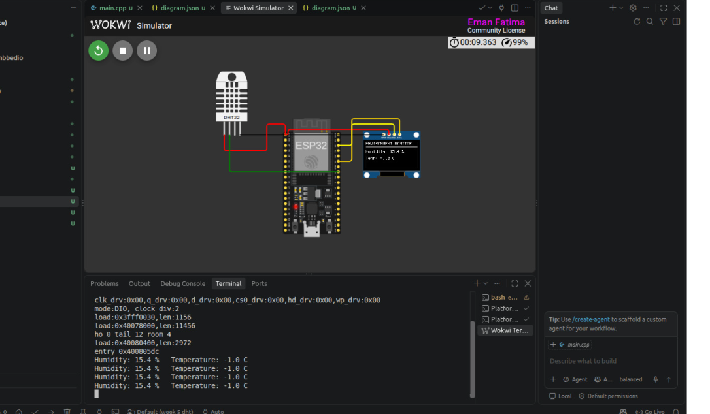
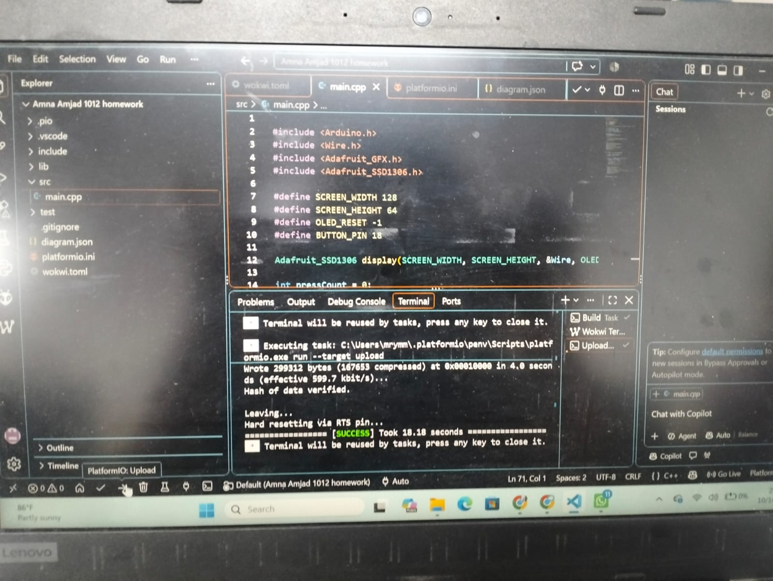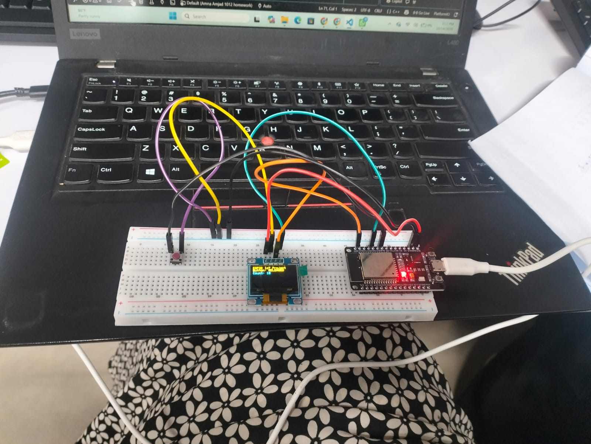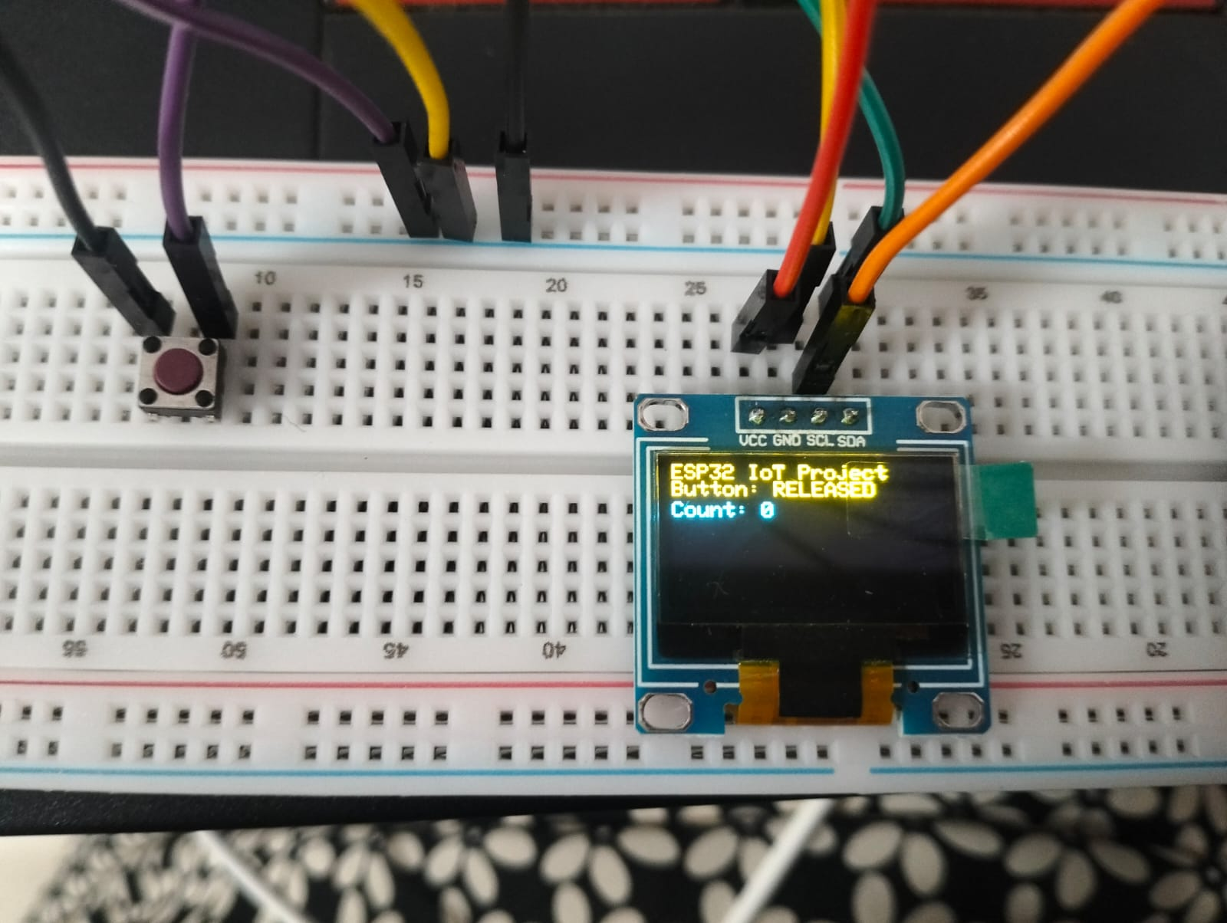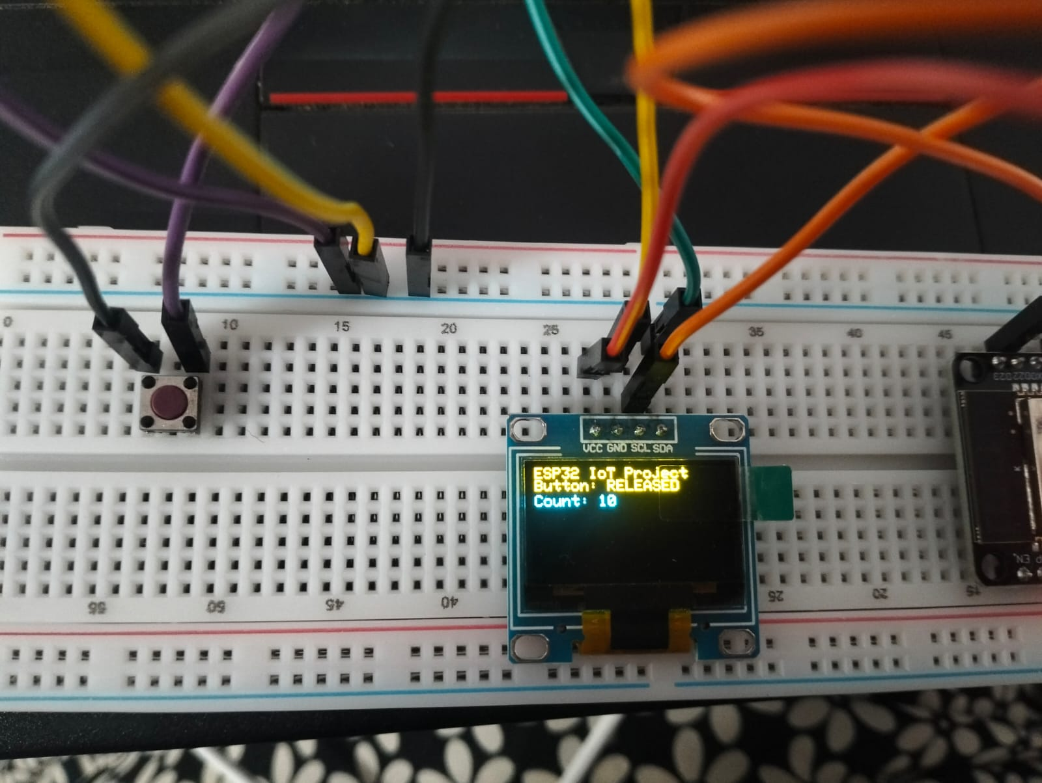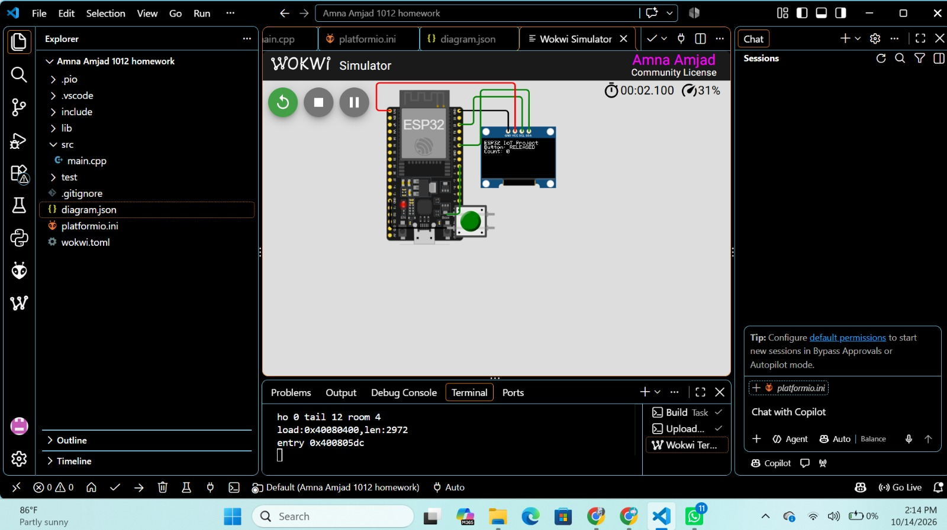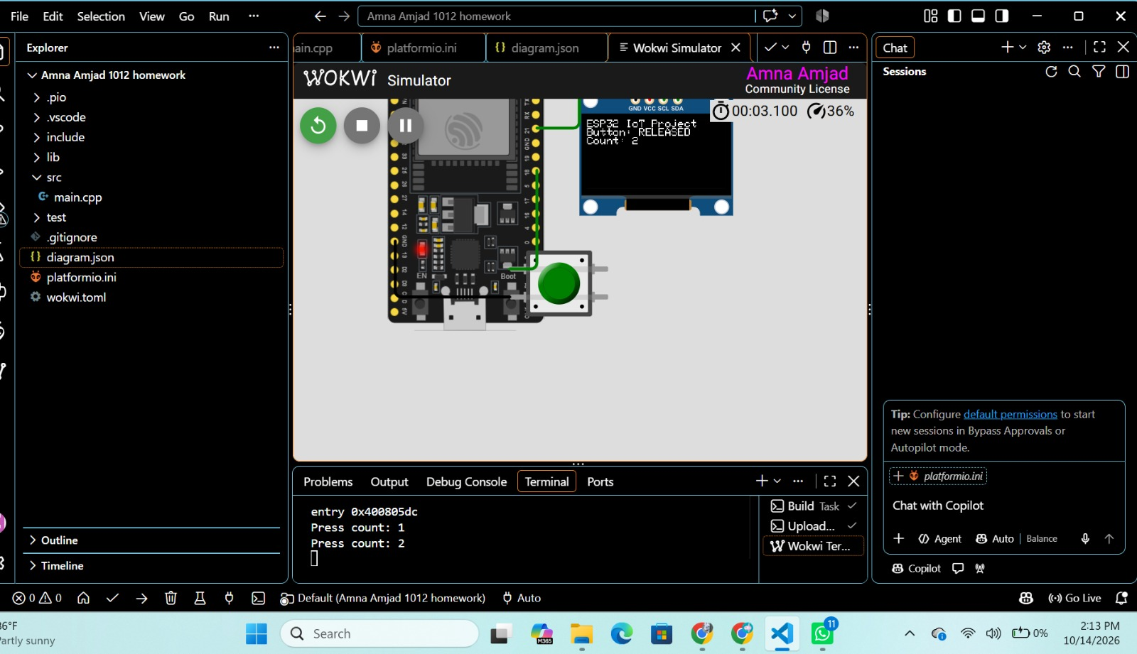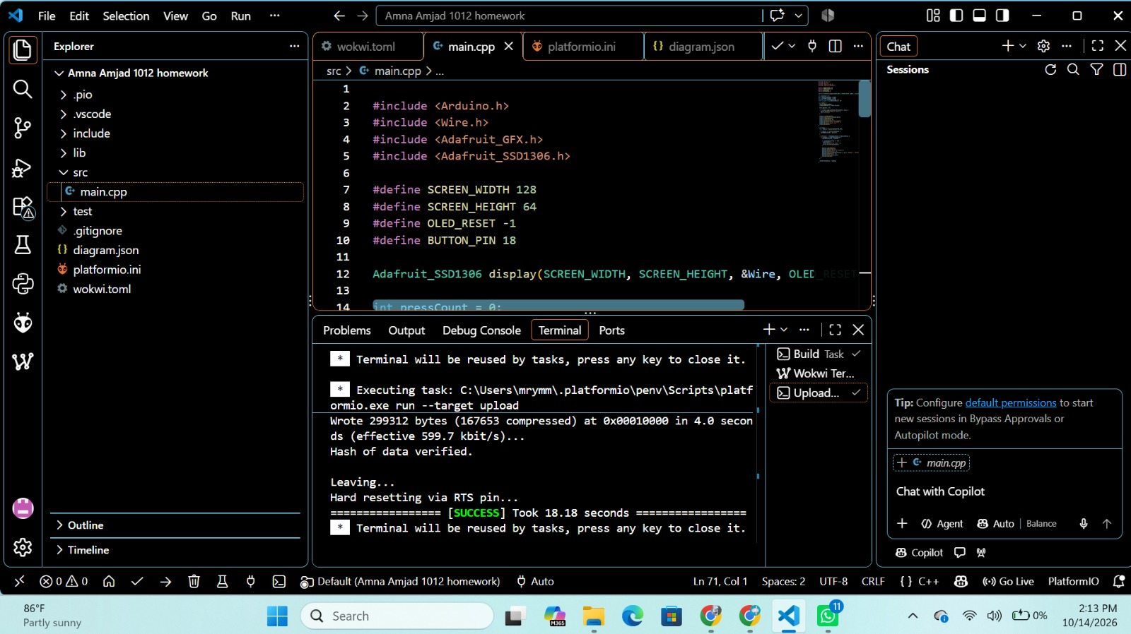
Conclusion
This project demonstrated how the ESP32, OLED display, and push button work together. The millis()-based debouncing technique helped ensure accurate button counting. Testing in Wokwi and on physical hardware provided practical experience with GPIO, I²C, and non-blocking programming.

